22-23 RHS ELPAC PERFORMANCE DATA

Overall yearly report + primary language performance



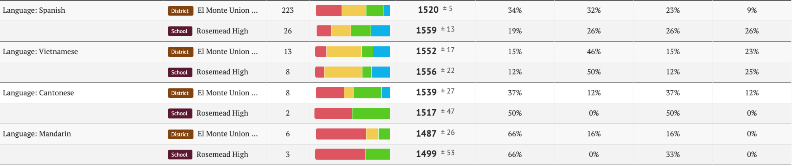



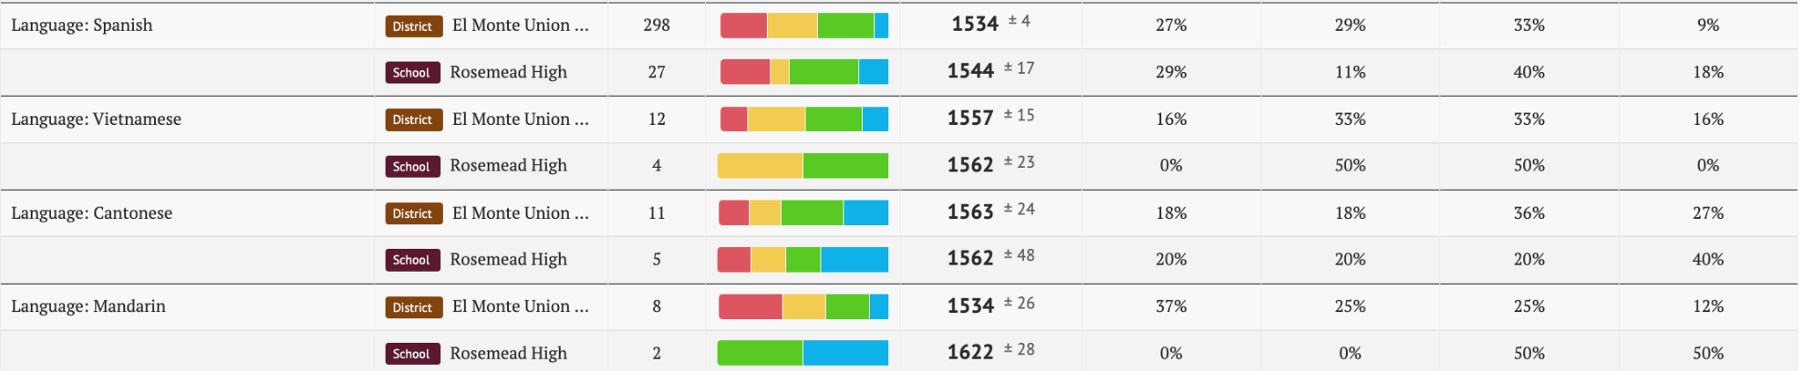



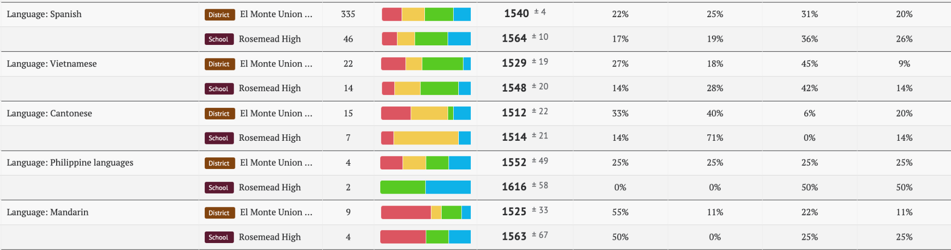



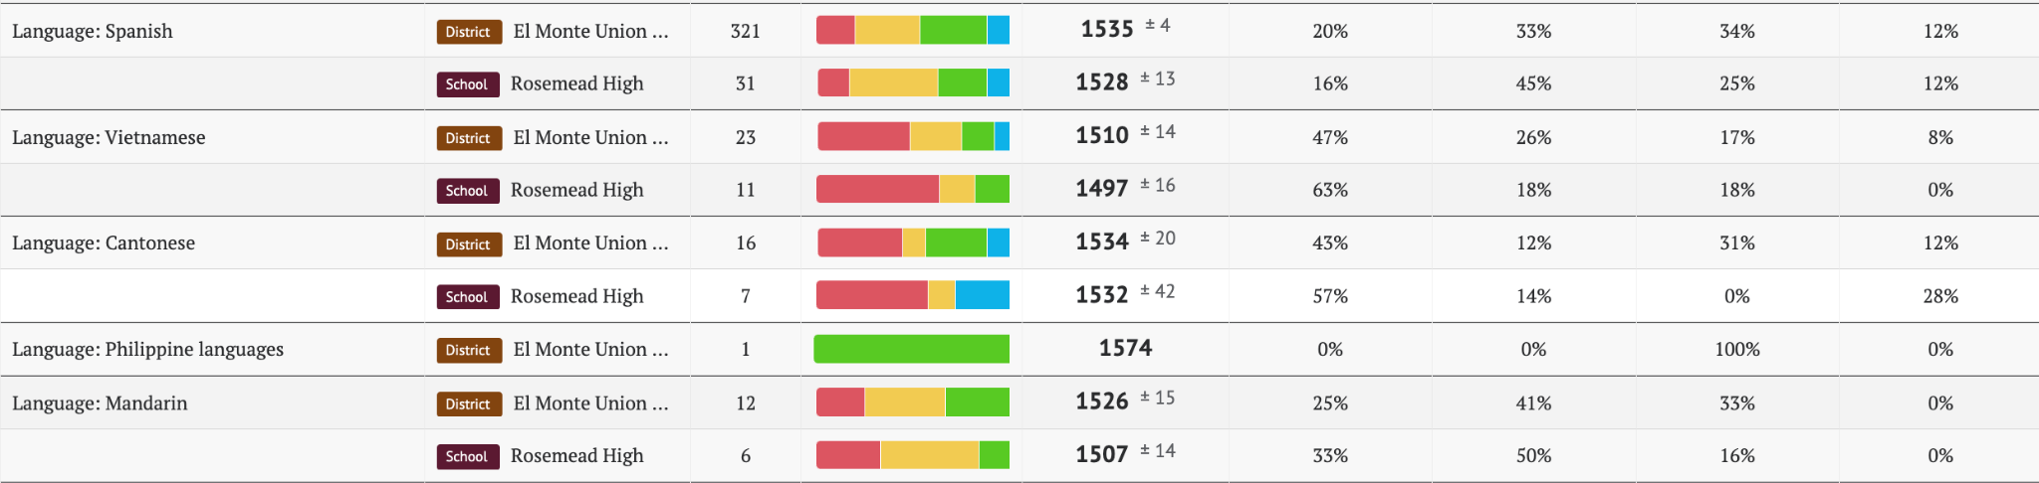

Performance by Domains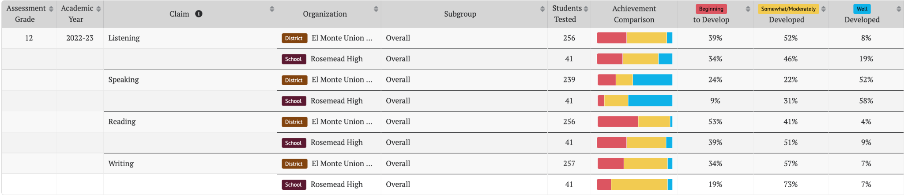

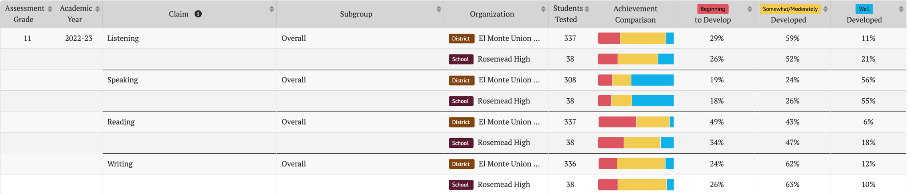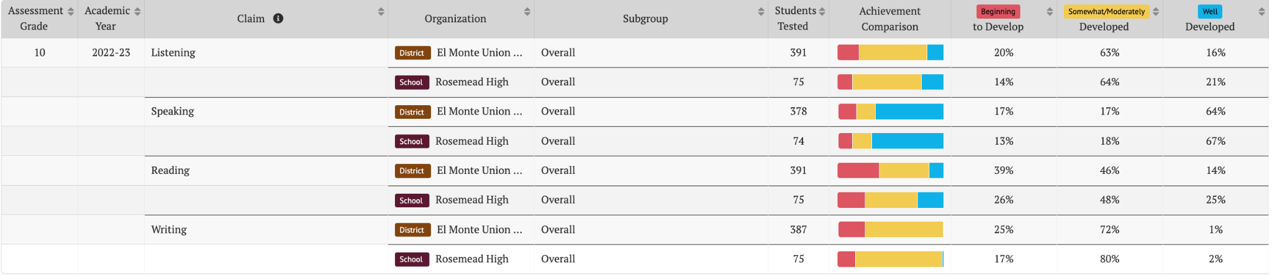

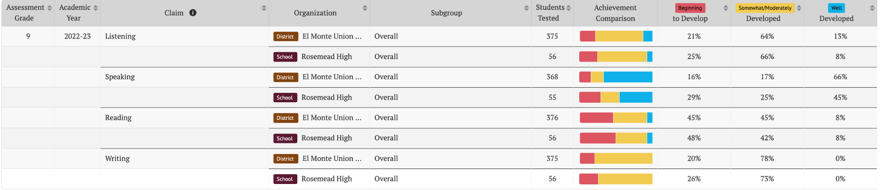

English Learners Performance in 22-23 CAASPP

ELA

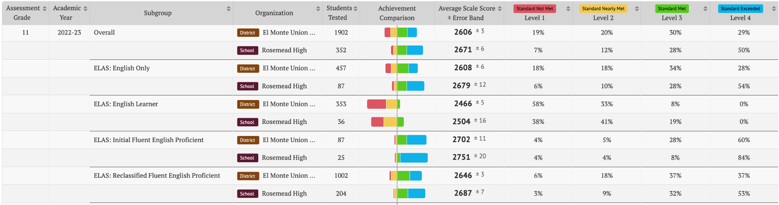

Math

